CELEBRATE SUCCESS WITH SURF

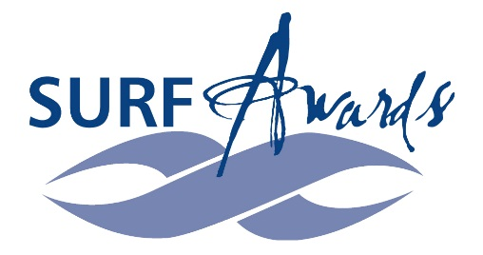
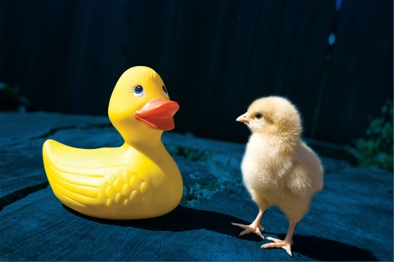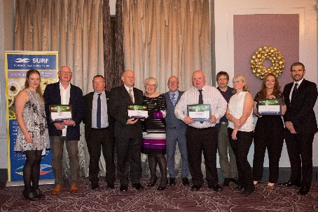

The 2017 SURF Awards Presentation Dinner

One of the top events in Scotland’s regeneration calendar

Thursday 7 December 2017, 6.30pm – late

The Grand Central Hotel, 99 Gordon St, Glasgow

SURF and the Scottish Government have teamed up again to deliver the prestigious SURF Awards for Best Practice in Community Regeneration for 2017. These are presented each year to projects that are judged by a panel of independent regeneration experts to be performing outstanding regeneration work in some of Scotland’s most disadvantaged communities.

The awards process concludes with a celebratory dinner event, at which a Scottish Government Minister will reveal the 2017 SURF Award category winners.

The convivial presentation dinner is an opportunity to join regeneration friends and colleagues from across all sectors to learn more about the latest examples of best practice and the quality and diversity of ongoing regeneration projects across Scotland.

The cost of attending is unchanged since 2005. To ensure your place at this great value event, please complete and return the booking form on page three.

SURF AWARDS PRESENTATION DINNER AGENDA

The format of the event is as follows:

Thursday 7 December 2017; Grand Central Hotel, Glasgow

18.30 Pre-dinner drinks and networking with music from Fèis Phàislig
19.00 Guests seated for dinner
19.15 Welcome from SURF Chair Kate Wimpress
19.20 Presentation of awards by a Scottish Government Minister
20.30 Dinner
21.50 After dinner speaker – Alan Bissett, playwright and author
22.10 Closing remarks by SURF Chair
22.15 Social networking and cash bar
00.30 Close

DRESS CODE

The SURF Awards Presentation Dinner is not a black tie event. The dress code is smart casual.

COST & PAYMENT

The cost of attending is: £80.00 (ex VAT) per individual place and £720.00 (ex VAT) for a table of 10.
Please return the form on the following page to SURF by post, fax or email by Wednesday 30 November to guarantee your place(s) at the awards dinner.

If you wish to include payment, cheques should be made payable to SURF. BACS payment should be made to Natwest Bank, Sort Code 60 30 21, A/c No. 29694191. An invoice will be issued for your records.

- Email: events@surf.scot
- Post: SURF, Orkney Street Enterprise Centre, 18-20 Orkney Street, Glasgow G51 2BX

FURTHER INFORMATION

For any enquiries about this event, please do not hesitate to contact SURF’s Emma Scott (0141 440 6392, emma@surf.scot).

General information on the 2017 SURF Awards is available on the SURF website:
www.surf.scot/surf-awards/

BOOKING FORM – 2017 SURF AWARDS PRESENTATION DINNER (07/12/17, GLASGOW)

INDIVIDUAL PLACE(S): Please reserve ___ place(s) for:

 | Name of Guest | Dietary or Mobility Requirements

1

2

3

4

5

6

7

8

TABLE OF TEN: Please reserve ___ table(s) for: Organisation Name: ________

 | Name of Guest | Dietary or Mobility Requirements

1

2

3

4

5

6

7

8

9

10

If booking a table, and you are unsure of the final guest list, then please submit this booking form and let us know the names of your guests separately by Thursday 30 November together with any dietary or mobility requirements. If booking more than one table, please send the names of your additional guests separately.

Please let us know who to send a booking confirmation and invoice to:

Name
Job Title
Organisation
Address
Telephone No.
Email Address
Please specify any special requirements here, e.g. Purchase Order No.

