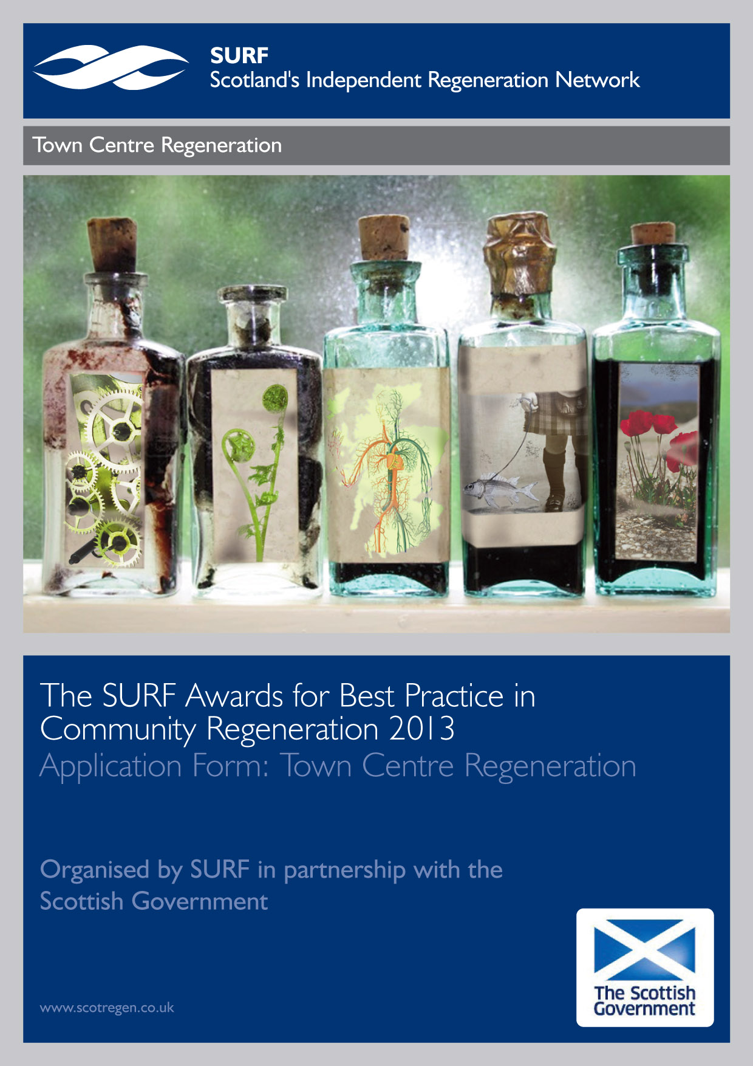

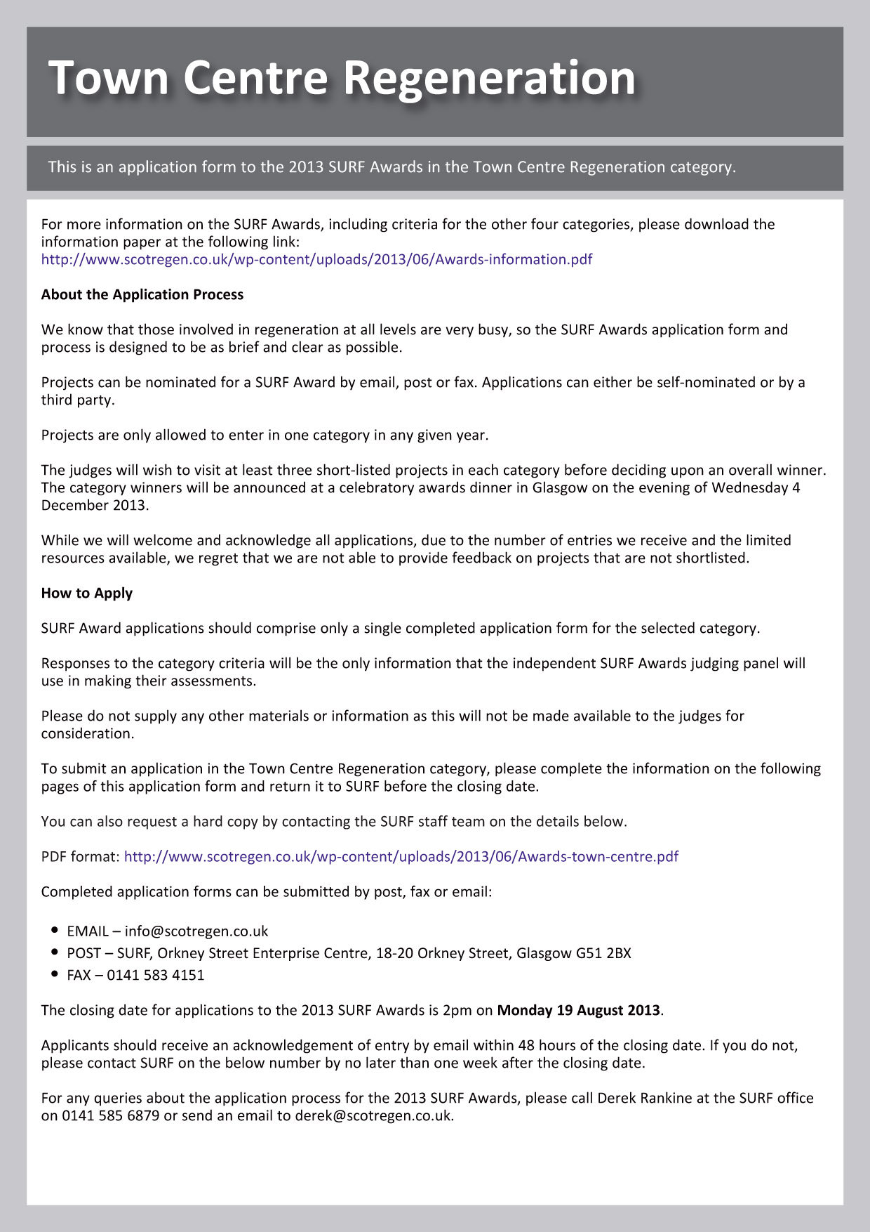

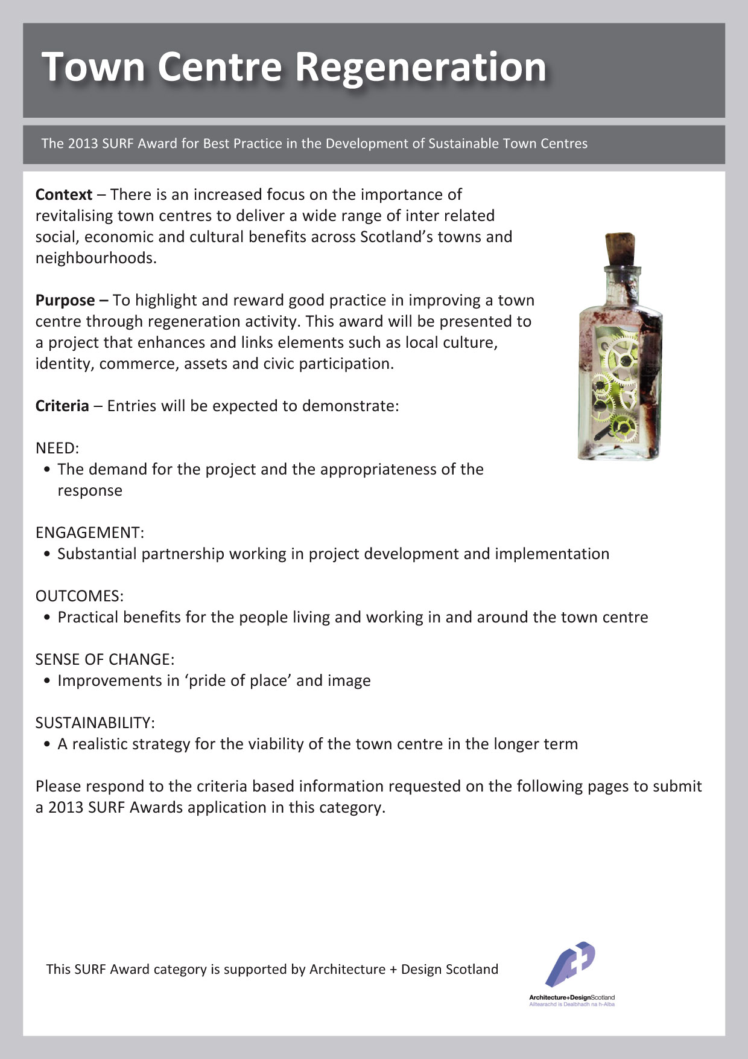

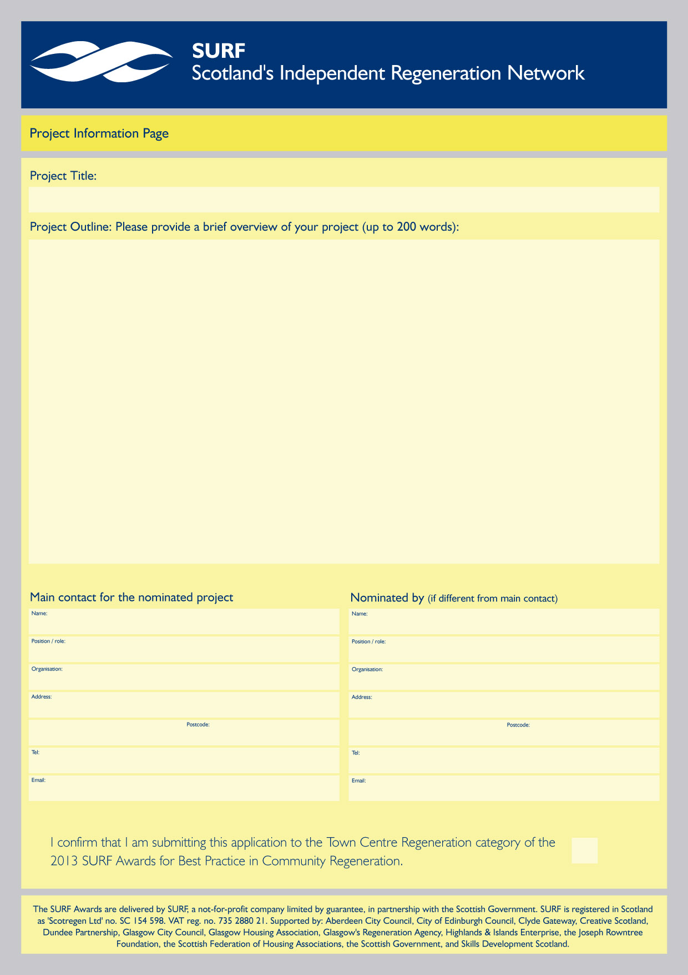

Name in here

Name in here

x
Enter text here
Project Title

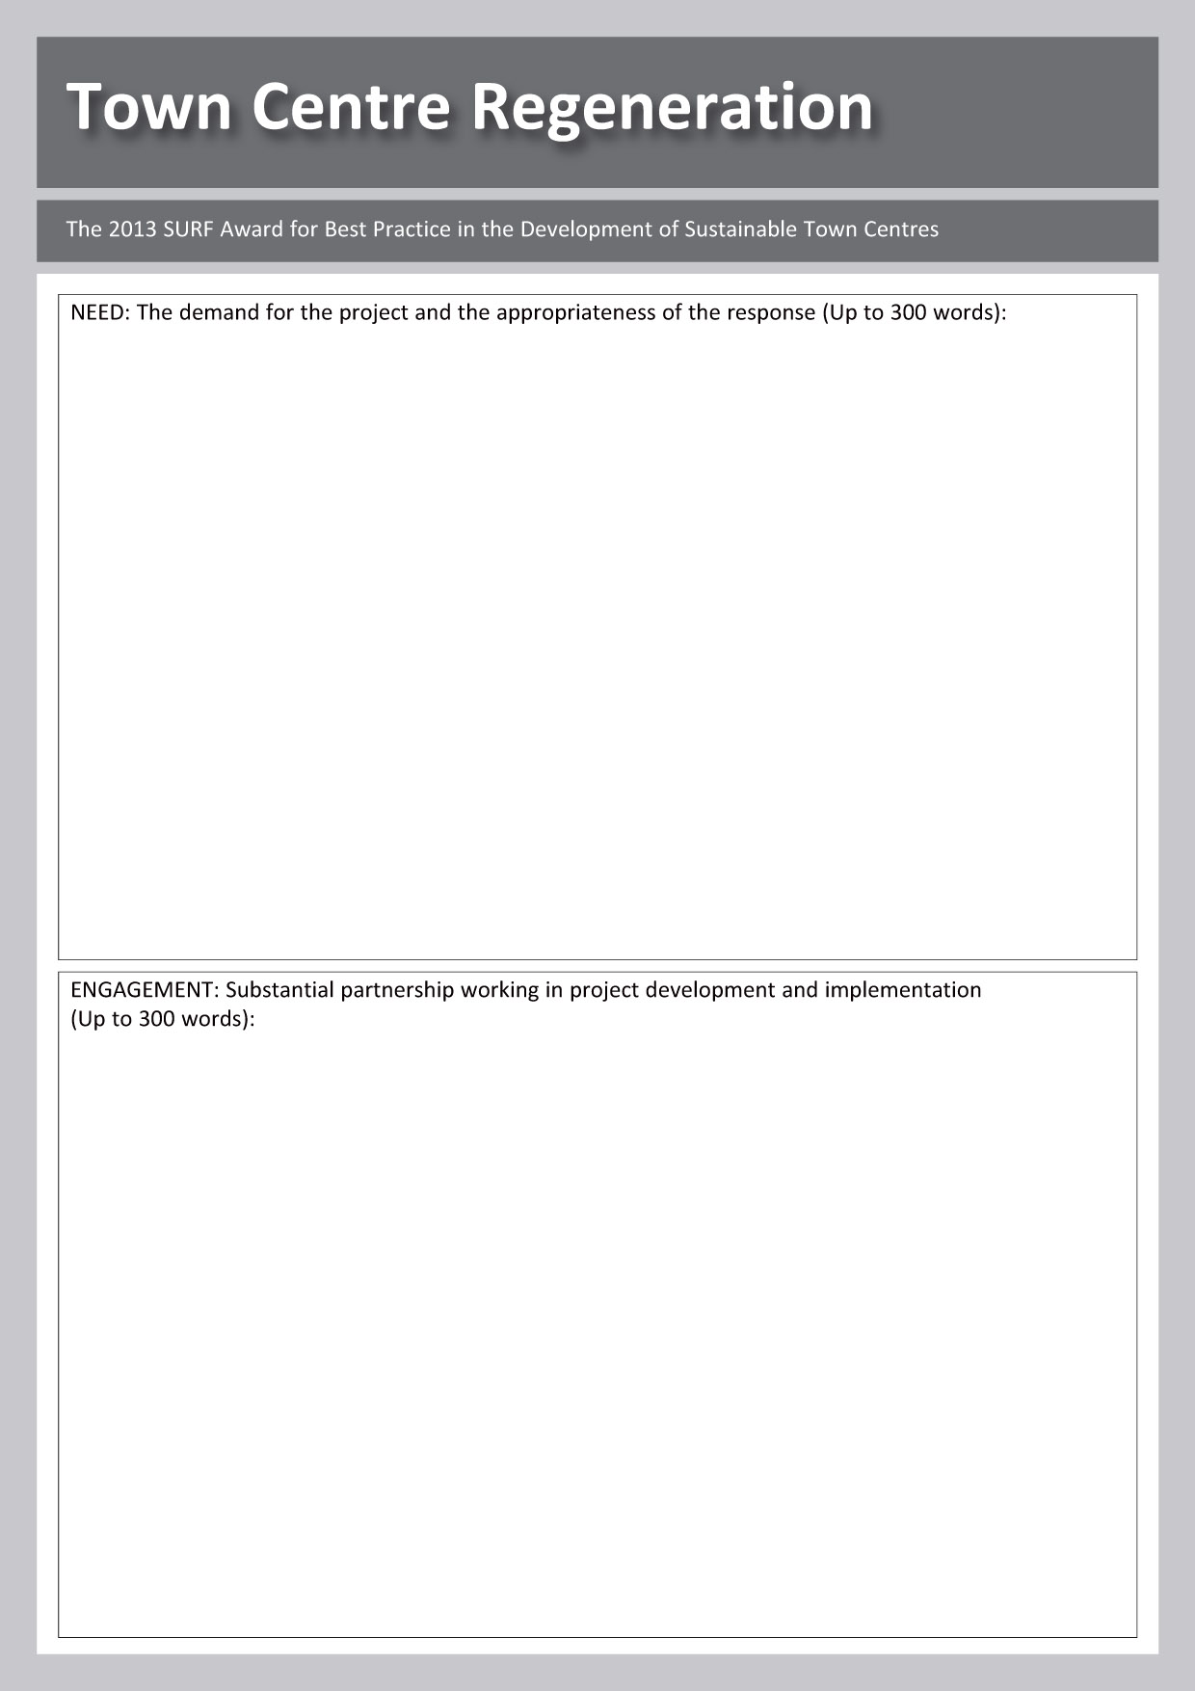

Enter text here
Enter text here

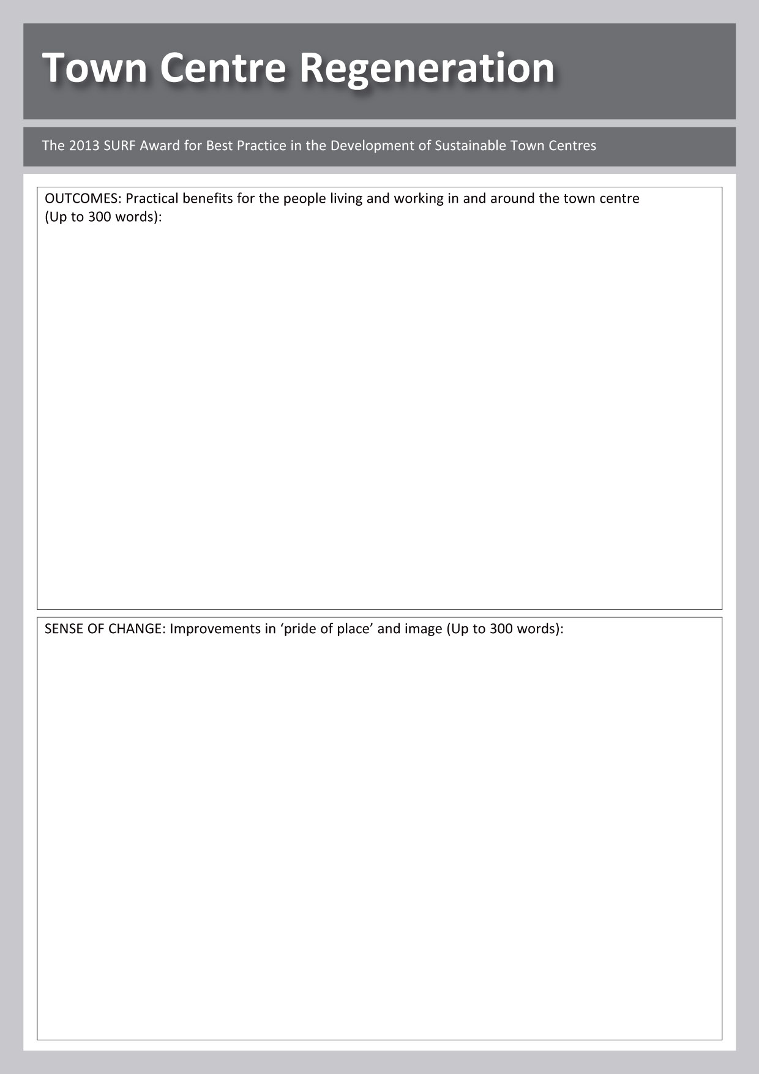

Enter text here

Enter text here

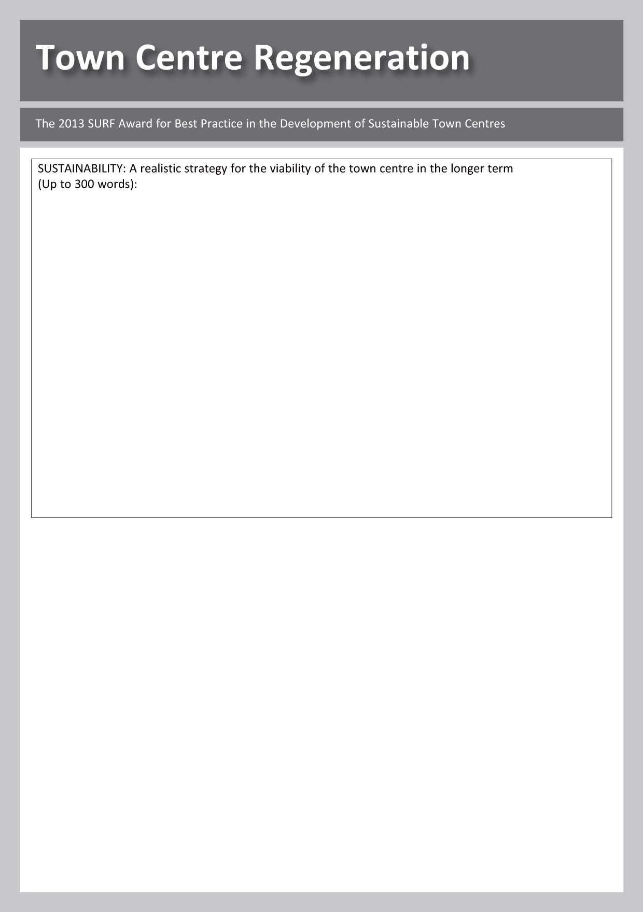

Enter text here



WHO ENTERS THE SURF AWARDS PROCESS AND WHY?
A SURF AWARDS 2013 MONITORING FORM

SURF, and the Scottish Government, who sponsor the SURF Awards, want to understand a bit more about what sort of projects are being reached in efforts to encourage entries.

We would be grateful if you could take just a few minutes to answer the questions below and simply return it to us with your SURF Awards 2013 entry application form. This information could help SURF secure continued support for the SURF Awards and further improve the application process.

N.B. The completed monitoring forms will not be seen by the judging panel and will form no part of the selection process. They are purely for gathering general information.

1) Marketing- How did you find out about the SURF Awards?
Please highlight your chosen option in bold.

- From the SURF website/e-bulletin
- From the Scottish Government website/e-bulletin
- From another newsletter/website/e-bulletin
- Social media (Twitter, Facebook etc.)
- Word of mouth
- Have applied previously
- Other - please specify:

2) Motivation- What is the main motivation for applying?
Please rank from 1-4, where 1=most important and 4=least important:
Enter a ‘1’ next to your first choice, ‘2’ next to the second choice, and so on.

- To spread awareness of the work being done
- To gather political support for the project
- To help secure future funding
- To give the staff and volunteers a morale boost
Other - please specify:

3) Membership- Is the nominating organisation currently a SURF member? N.B. this has no effect on the outcome of your application.

Please delete as appropriate: YES / NO

4) Geographical scope of the project
Please highlight your chosen option in bold.

- Immediate neighbourhood (up to 5k population)
- Local area (up to 10K population)
- Town/Citywide
- Regional
- National

5) Target groups
Which of the following groups of people are intended to benefit most from the work of the project?
Please highlight in bold all of the options that apply.

Children Disabled people
Young people People from ethnic minority groups
Older people All local residents

6) Sector
Which of the following is closest to describing the applicant organisation?
Please highlight your chosen option in bold.

A community group An academic organisation
A voluntary organisation A private sector organisation
A public sector organisation

If none of the above fit, even in general terms, please say how you would categorise it here:

Resources
7) What is the current financial turnover of the project you are nominating?
Please highlight your chosen option in bold.

Less than £3000 £50K – 250K
£3000 - £10K More than £250K
£10k – 50k

8) How many paid staff, as full time equivalent positions, are employed to work on the project being nominated?
Please highlight your chosen option in bold.

None 4 to 8
0.5 to 3 9 or more

8) How many volunteers are involved in managing the project? Enter number:
and how many in the delivery of the project’s work? Enter number:

Thank you very much for taking the time to complete this form. The form will be removed from the rest of your application before it is passed to members of the independent judging panel.

