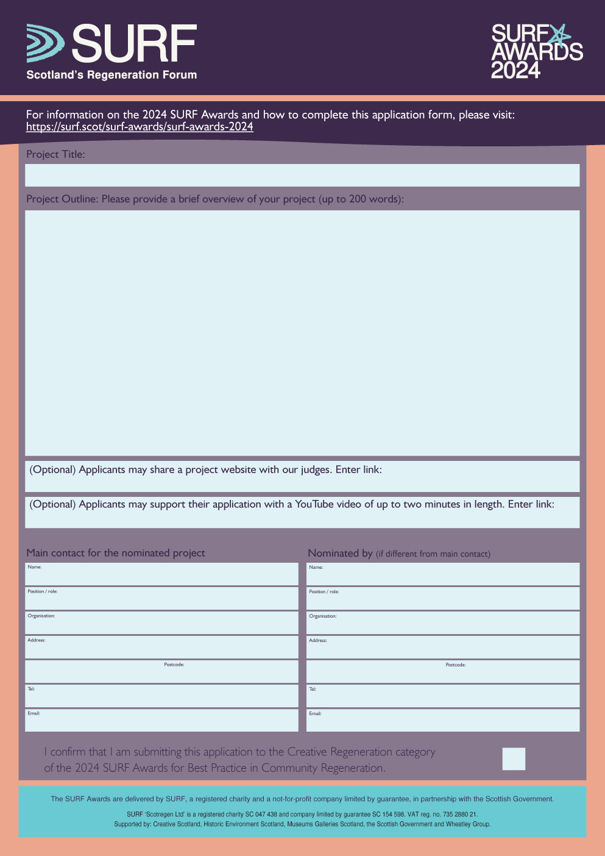

Name in here
X
Lorem ipsum dolor sit amet, consectetur adipiscing elit. Suspendisse ornare dolor vel rutrum luctus. Morbi eget orci a arcu ornare imperdiet non a enim. Nulla lobortis congue orci, imperdiet ultrices sapien vestibulum non. Sed nec ornare sapien. Proin pulvinar aliquam justo non dignissim. Pellentesque habitant morbi tristique senectus et netus et malesuada fames ac turpis egestas. Vivamus rutrum neque tellus, id dapibus mi gravida vitae. Aliquam erat volutpat. Sed sit amet vulputate nibh, et lacinia lectus. Aenean lobortis ante id luctus cursus. Duis elementum mi pretium facilisis mattis. Lorem ipsum dolor sit amet, consectetur adipiscing elit. Maecenas eleifend luctus molestie. Vestibulum enim leo, viverra nec eros id, auctor fringilla mauris.
Vivamus varius vulputate ante nec bibendum. Integer nec lectus vel nulla venenatis pulvinar. Phasellus sollicitudin interdum metus ut ultricies. Phasellus ac sodales justo, eget pharetra sapien. Pellentesque luctus, lorem quis tristique consectetur, tortor metus eleifend felis, non hendrerit arcu sapien sit amet tellus. Quisque convallis nulla quis augue semper sodales sed at lacus. Etiam pellentesque tellus erat, quis bibendum dolor ornare ac. Proin rutrum, dolor sit amet dignissim pulvinar, nulla ligula dictum nulla, ut ornare libero quam a elit. Donec elementum purus vitae risus tempus ultrices vitae ut dui. Quisque.
Project Title

Youtube URL in here
Position in here
Organisation in here
Address in here
Address cont. in here
Tel no. here
Email address here
Postcode here
Name in here
Position in here
Organisation in here
Address in here
Address cont. in here
Tel no. here
Email address here
Postcode here

Website URL in here

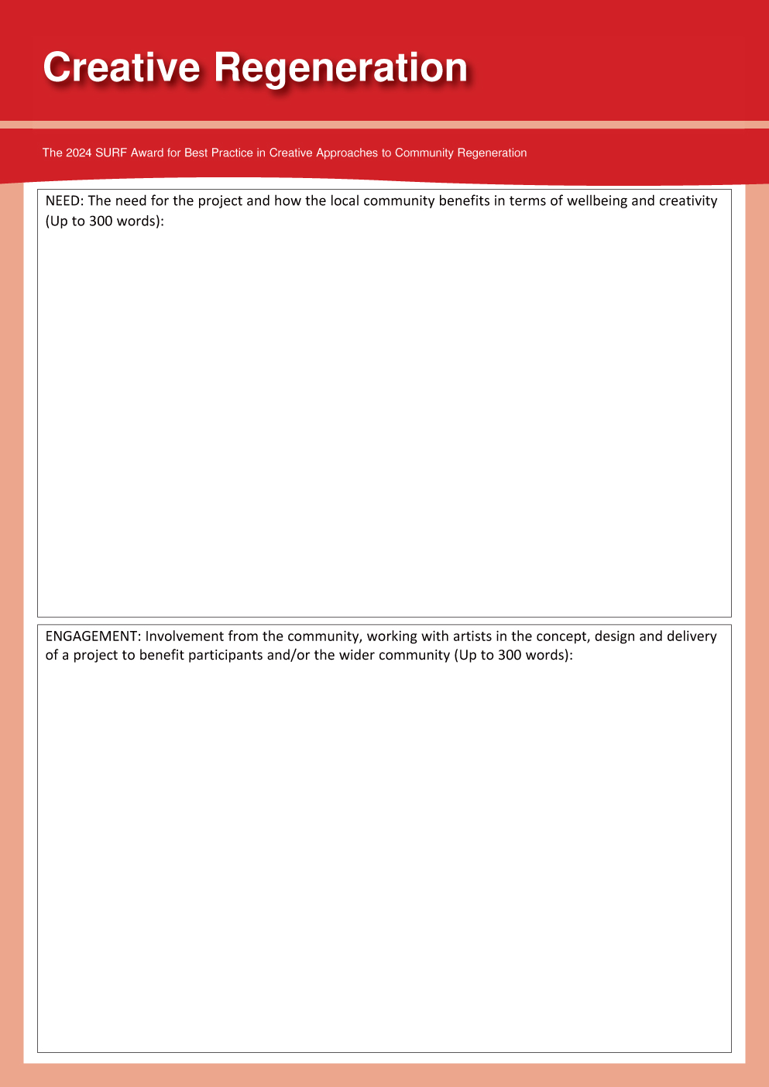

Lorem ipsum dolor sit amet, consectetur adipiscing elit. Vestibulum metus turpis, dictum ut ante eget, ultrices vehicula purus. Nulla nec laoreet lorem, eget congue tortor. Maecenas id nisl lacus. Donec accumsan magna id sem porta luctus. Nullam sodales bibendum lacus, ut semper enim. Vivamus faucibus laoreet quam eu malesuada. Cras condimentum sapien magna, eu adipiscing nunc lacinia at. Mauris interdum congue turpis in accumsan.
Nunc eu suscipit justo, id feugiat felis. Duis viverra felis orci, ac interdum ipsum sodales vel. Curabitur rutrum cursus porta. Class aptent taciti sociosqu ad litora torquent per conubia nostra, per inceptos himenaeos. Etiam sit amet porttitor est. Mauris interdum sollicitudin aliquet. Nunc vitae lorem sagittis, convallis nunc tincidunt, convallis sem. Fusce id sapien ipsum. Nam imperdiet egestas quam, id viverra nulla ultricies sit amet. Maecenas ac gravida odio.
Maecenas posuere interdum felis id rhoncus. Nam ultrices vulputate nisl, et vulputate arcu iaculis id. Nulla facilisis congue lectus ultricies tincidunt. Ut bibendum at orci nec lobortis. Vivamus ultricies vel justo mattis lobortis. Suspendisse lobortis adipiscing nulla vitae mollis. Etiam dui enim, pharetra sit amet porttitor rhoncus, fermentum ac justo. Maecenas ultricies sit amet tortor at molestie. Phasellus nibh dui, interdum et ultricies tincidunt, tincidunt a enim. Aenean rhoncus imperdiet dui, vitae hendrerit nulla pretium vitae. Quisque placerat ornare fermentum.
Nulla tristique, elit non feugiat malesuada, nulla erat volutpat odio, nec varius lacus tellus at quam. Duis neque odio, faucibus ac eros vel, consectetur placerat turpis. Morbi et nisl justo. Phasellus nec lacus nec lectus fermentum fringilla in sed enim. Nullam viverra, eros vel tristique scelerisque, sapien elit tincidunt lacus, nec tempus felis neque eget felis. Donec vitae mauris sed nulla scelerisque viverra vel sed eros. Nam semper lectus ante, vel vulputate magna consequat eu. Curabitur mollis nunc lectus, et gravida nibh laoreet dignissim. Maecenas et enim.

Lorem ipsum dolor sit amet, consectetur adipiscing elit. Vestibulum metus turpis, dictum ut ante eget, ultrices vehicula purus. Nulla nec laoreet lorem, eget congue tortor. Maecenas id nisl lacus. Donec accumsan magna id sem porta luctus. Nullam sodales bibendum lacus, ut semper enim. Vivamus faucibus laoreet quam eu malesuada. Cras condimentum sapien magna, eu adipiscing nunc lacinia at. Mauris interdum congue turpis in accumsan.
Nunc eu suscipit justo, id feugiat felis. Duis viverra felis orci, ac interdum ipsum sodales vel. Curabitur rutrum cursus porta. Class aptent taciti sociosqu ad litora torquent per conubia nostra, per inceptos himenaeos. Etiam sit amet porttitor est. Mauris interdum sollicitudin aliquet. Nunc vitae lorem sagittis, convallis nunc tincidunt, convallis sem. Fusce id sapien ipsum. Nam imperdiet egestas quam, id viverra nulla ultricies sit amet. Maecenas ac gravida odio.
Maecenas posuere interdum felis id rhoncus. Nam ultrices vulputate nisl, et vulputate arcu iaculis id. Nulla facilisis congue lectus ultricies tincidunt. Ut bibendum at orci nec lobortis. Vivamus ultricies vel justo mattis lobortis. Suspendisse lobortis adipiscing nulla vitae mollis. Etiam dui enim, pharetra sit amet porttitor rhoncus, fermentum ac justo. Maecenas ultricies sit amet tortor at molestie. Phasellus nibh dui, interdum et ultricies tincidunt, tincidunt a enim. Aenean rhoncus imperdiet dui, vitae hendrerit nulla pretium vitae. Quisque placerat ornare fermentum.
Nulla tristique, elit non feugiat malesuada, nulla erat volutpat odio, nec varius lacus tellus at quam. Duis neque odio, faucibus ac eros vel, consectetur placerat turpis. Morbi et nisl justo. Phasellus nec lacus nec lectus fermentum fringilla in sed enim. Nullam viverra, eros vel tristique scelerisque, sapien elit tincidunt lacus, nec tempus felis neque eget felis. Donec vitae mauris sed nulla scelerisque viverra vel sed eros. Nam semper lectus ante, vel vulputate magna consequat eu. Curabitur mollis nunc lectus, et gravida nibh laoreet dignissim. Maecenas et enim.

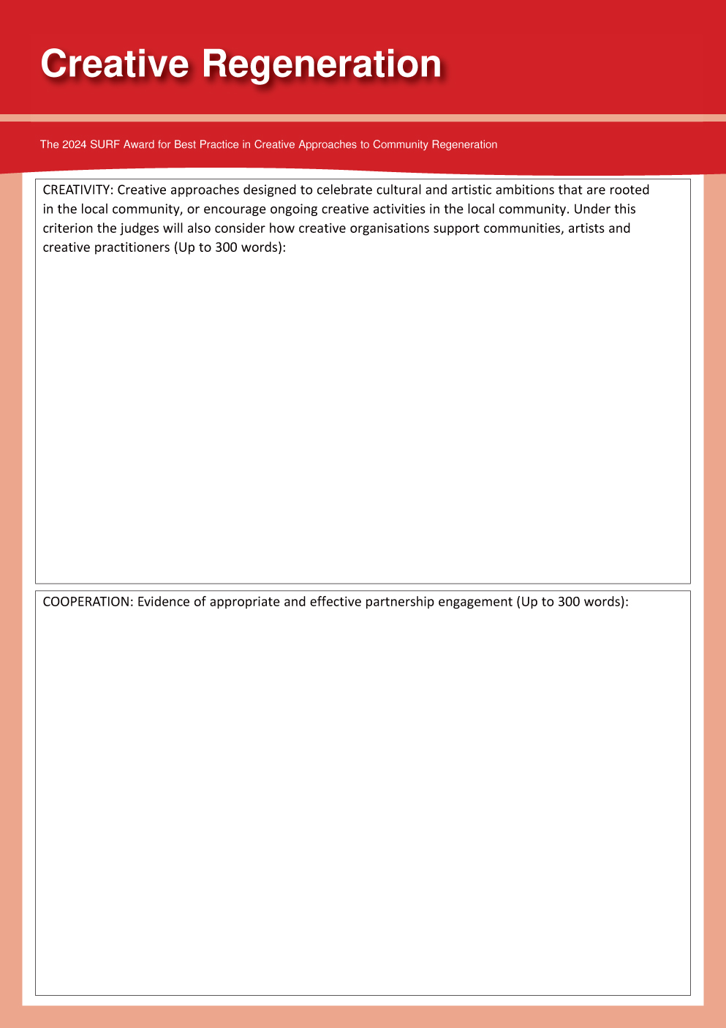
Lorem ipsum dolor sit amet, consectetur adipiscing elit. Vestibulum metus turpis, dictum ut ante eget, ultrices vehicula purus. Nulla nec laoreet lorem, eget congue tortor. Maecenas id nisl lacus. Donec accumsan magna id sem porta luctus. Nullam sodales bibendum lacus, ut semper enim. Vivamus faucibus laoreet quam eu malesuada. Cras condimentum sapien magna, eu adipiscing nunc lacinia at. Mauris interdum congue turpis in accumsan.
Nunc eu suscipit justo, id feugiat felis. Duis viverra felis orci, ac interdum ipsum sodales vel. Curabitur rutrum cursus porta. Class aptent taciti sociosqu ad litora torquent per conubia nostra, per inceptos himenaeos. Etiam sit amet porttitor est. Mauris interdum sollicitudin aliquet. Nunc vitae lorem sagittis, convallis nunc tincidunt, convallis sem. Fusce id sapien ipsum. Nam imperdiet egestas quam, id viverra nulla ultricies sit amet. Maecenas ac gravida odio.
Maecenas posuere interdum felis id rhoncus. Nam ultrices vulputate nisl, et vulputate arcu iaculis id. Nulla facilisis congue lectus ultricies tincidunt. Ut bibendum at orci nec lobortis. Vivamus ultricies vel justo mattis lobortis. Suspendisse lobortis adipiscing nulla vitae mollis. Etiam dui enim, pharetra sit amet porttitor rhoncus, fermentum ac justo. Maecenas ultricies sit amet tortor at molestie. Phasellus nibh dui, interdum et ultricies tincidunt, tincidunt a enim. Aenean rhoncus imperdiet dui, vitae hendrerit nulla pretium vitae. Quisque placerat ornare fermentum.
Nulla tristique, elit non feugiat malesuada, nulla erat volutpat odio, nec varius lacus tellus at quam. Duis neque odio, faucibus ac eros vel, consectetur placerat turpis. Morbi et nisl justo. Phasellus nec lacus nec lectus fermentum fringilla in sed enim. Nullam viverra, eros vel tristique scelerisque, sapien elit tincidunt lacus, nec tempus felis neque eget felis. Donec vitae mauris sed nulla scelerisque viverra vel sed eros. Nam semper lectus ante, vel vulputate magna consequat eu. Curabitur mollis nunc lectus, et gravida nibh laoreet dignissim. Maecenas et enim.

Lorem ipsum dolor sit amet, consectetur adipiscing elit. Vestibulum metus turpis, dictum ut ante eget, ultrices vehicula purus. Nulla nec laoreet lorem, eget congue tortor. Maecenas id nisl lacus. Donec accumsan magna id sem porta luctus. Nullam sodales bibendum lacus, ut semper enim. Vivamus faucibus laoreet quam eu malesuada. Cras condimentum sapien magna, eu adipiscing nunc lacinia at. Mauris interdum congue turpis in accumsan.
Nunc eu suscipit justo, id feugiat felis. Duis viverra felis orci, ac interdum ipsum sodales vel. Curabitur rutrum cursus porta. Class aptent taciti sociosqu ad litora torquent per conubia nostra, per inceptos himenaeos. Etiam sit amet porttitor est. Mauris interdum sollicitudin aliquet. Nunc vitae lorem sagittis, convallis nunc tincidunt, convallis sem. Fusce id sapien ipsum. Nam imperdiet egestas quam, id viverra nulla ultricies sit amet. Maecenas ac gravida odio.
Maecenas posuere interdum felis id rhoncus. Nam ultrices vulputate nisl, et vulputate arcu iaculis id. Nulla facilisis congue lectus ultricies tincidunt. Ut bibendum at orci nec lobortis. Vivamus ultricies vel justo mattis lobortis. Suspendisse lobortis adipiscing nulla vitae mollis. Etiam dui enim, pharetra sit amet porttitor rhoncus, fermentum ac justo. Maecenas ultricies sit amet tortor at molestie. Phasellus nibh dui, interdum et ultricies tincidunt, tincidunt a enim. Aenean rhoncus imperdiet dui, vitae hendrerit nulla pretium vitae. Quisque placerat ornare fermentum.
Nulla tristique, elit non feugiat malesuada, nulla erat volutpat odio, nec varius lacus tellus at quam. Duis neque odio, faucibus ac eros vel, consectetur placerat turpis. Morbi et nisl justo. Phasellus nec lacus nec lectus fermentum fringilla in sed enim. Nullam viverra, eros vel tristique scelerisque, sapien elit tincidunt lacus, nec tempus felis neque eget felis. Donec vitae mauris sed nulla scelerisque viverra vel sed eros. Nam semper lectus ante, vel vulputate magna consequat eu. Curabitur mollis nunc lectus, et gravida nibh laoreet dignissim. Maecenas et enim.

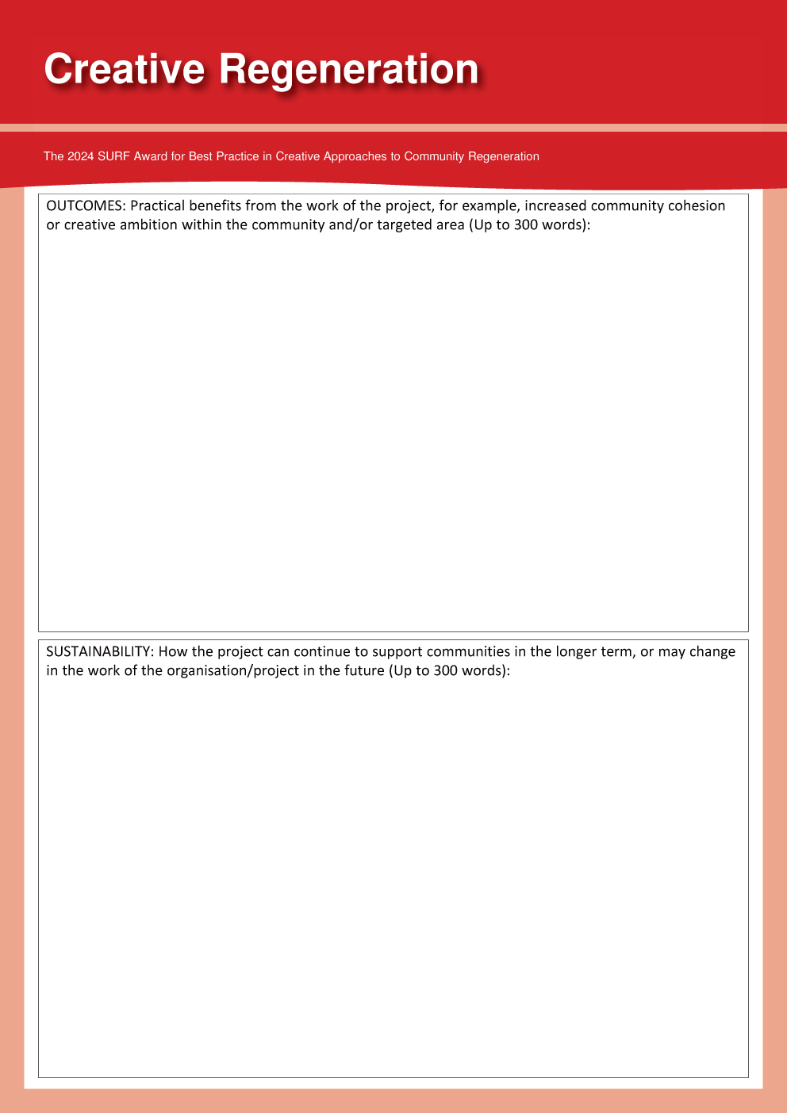

Lorem ipsum dolor sit amet, consectetur adipiscing elit. Vestibulum metus turpis, dictum ut ante eget, ultrices vehicula purus. Nulla nec laoreet lorem, eget congue tortor. Maecenas id nisl lacus. Donec accumsan magna id sem porta luctus. Nullam sodales bibendum lacus, ut semper enim. Vivamus faucibus laoreet quam eu malesuada. Cras condimentum sapien magna, eu adipiscing nunc lacinia at. Mauris interdum congue turpis in accumsan.
Nunc eu suscipit justo, id feugiat felis. Duis viverra felis orci, ac interdum ipsum sodales vel. Curabitur rutrum cursus porta. Class aptent taciti sociosqu ad litora torquent per conubia nostra, per inceptos himenaeos. Etiam sit amet porttitor est. Mauris interdum sollicitudin aliquet. Nunc vitae lorem sagittis, convallis nunc tincidunt, convallis sem. Fusce id sapien ipsum. Nam imperdiet egestas quam, id viverra nulla ultricies sit amet. Maecenas ac gravida odio.
Maecenas posuere interdum felis id rhoncus. Nam ultrices vulputate nisl, et vulputate arcu iaculis id. Nulla facilisis congue lectus ultricies tincidunt. Ut bibendum at orci nec lobortis. Vivamus ultricies vel justo mattis lobortis. Suspendisse lobortis adipiscing nulla vitae mollis. Etiam dui enim, pharetra sit amet porttitor rhoncus, fermentum ac justo. Maecenas ultricies sit amet tortor at molestie. Phasellus nibh dui, interdum et ultricies tincidunt, tincidunt a enim. Aenean rhoncus imperdiet dui, vitae hendrerit nulla pretium vitae. Quisque placerat ornare fermentum.
Nulla tristique, elit non feugiat malesuada, nulla erat volutpat odio, nec varius lacus tellus at quam. Duis neque odio, faucibus ac eros vel, consectetur placerat turpis. Morbi et nisl justo. Phasellus nec lacus nec lectus fermentum fringilla in sed enim. Nullam viverra, eros vel tristique scelerisque, sapien elit tincidunt lacus, nec tempus felis neque eget felis. Donec vitae mauris sed nulla scelerisque viverra vel sed eros. Nam semper lectus ante, vel vulputate magna consequat eu. Curabitur mollis nunc lectus, et gravida nibh laoreet dignissim. Maecenas et enim.

Lorem ipsum dolor sit amet, consectetur adipiscing elit. Vestibulum metus turpis, dictum ut ante eget, ultrices vehicula purus. Nulla nec laoreet lorem, eget congue tortor. Maecenas id nisl lacus. Donec accumsan magna id sem porta luctus. Nullam sodales bibendum lacus, ut semper enim. Vivamus faucibus laoreet quam eu malesuada. Cras condimentum sapien magna, eu adipiscing nunc lacinia at. Mauris interdum congue turpis in accumsan.
Nunc eu suscipit justo, id feugiat felis. Duis viverra felis orci, ac interdum ipsum sodales vel. Curabitur rutrum cursus porta. Class aptent taciti sociosqu ad litora torquent per conubia nostra, per inceptos himenaeos. Etiam sit amet porttitor est. Mauris interdum sollicitudin aliquet. Nunc vitae lorem sagittis, convallis nunc tincidunt, convallis sem. Fusce id sapien ipsum. Nam imperdiet egestas quam, id viverra nulla ultricies sit amet. Maecenas ac gravida odio.
Maecenas posuere interdum felis id rhoncus. Nam ultrices vulputate nisl, et vulputate arcu iaculis id. Nulla facilisis congue lectus ultricies tincidunt. Ut bibendum at orci nec lobortis. Vivamus ultricies vel justo mattis lobortis. Suspendisse lobortis adipiscing nulla vitae mollis. Etiam dui enim, pharetra sit amet porttitor rhoncus, fermentum ac justo. Maecenas ultricies sit amet tortor at molestie. Phasellus nibh dui, interdum et ultricies tincidunt, tincidunt a enim. Aenean rhoncus imperdiet dui, vitae hendrerit nulla pretium vitae. Quisque placerat ornare fermentum.
Nulla tristique, elit non feugiat malesuada, nulla erat volutpat odio, nec varius lacus tellus at quam. Duis neque odio, faucibus ac eros vel, consectetur placerat turpis. Morbi et nisl justo. Phasellus nec lacus nec lectus fermentum fringilla in sed enim. Nullam viverra, eros vel tristique scelerisque, sapien elit tincidunt lacus, nec tempus felis neque eget felis. Donec vitae mauris sed nulla scelerisque viverra vel sed eros. Nam semper lectus ante, vel vulputate magna consequat eu. Curabitur mollis nunc lectus, et gravida nibh laoreet dignissim. Maecenas et enim.

WHO ENTERS THE SURF AWARDS PROCESS AND WHY?
A SURF AWARDS 2024 MONITORING FORM

SURF, and the Scottish Government, who sponsor the SURF Awards, want to understand a bit more about what sort of projects are being reached in efforts to encourage entries.

We would be grateful if you could take just a few minutes to answer the questions below and simply return it to us with your SURF Awards 2024 entry application form. This information could help SURF secure continued support for the SURF Awards and further improve the application process.

N.B. The completed monitoring forms will not be seen by the judging panel and will form no part of the selection process. They are purely for gathering general information.

- Marketing- How did you find out about the SURF Awards?
Please tick

          From the SURF website/e-bulletin
          From the Scottish Government website/e-bulletin
          From another newsletter/website/e-bulletin
          Social media (Twitter, Facebook etc.)
          Word of mouth
          Have applied previously
          Other - please specify:

2) Motivation- What is the main motivation for applying?
Please rank from 1-4, where 1=most important and 4=least important:
Enter a ‘1’ next to your first choice, ‘2’ next to the second choice,
and so on.

          To spread awareness of the work being done
          To gather political support for the project
          To help secure future funding
          To give the staff and volunteers a morale boost
          Other - please specify:

3) Membership- Is the nominating organisation currently a SURF member?
N.B. this has no effect on the outcome of your application.

Please delete as appropriate: YES / NO / UNSURE

4) Geographical scope of the project
Please tick

 Immediate neighbourhood (up to 5k population)
 Local area (up to 10K population)
 Town/Citywide
 Regional
 National

5) Target groups
Which of the following groups of people are intended to benefit most from the work of the project?
Please tick all of the options that apply

  Children   Disabled people
  Young people   People from ethnic minority groups
  Older people   All local residents

6) Sector
Which of the following is closest to describing the applicant organisation?
Please tick

  A community group   An academic organisation      
  A voluntary organisation   A private sector organisation   A public sector organisation

If none of the above fit, even in general terms, please say how you would categorise it here:

Resources
7) What is the current financial turnover of the project you are nominating?
Please tick

  Less than £3000         £50K – 250K
  £3000 - £10K         More than £250K
  £10k – 50k

8) How many paid staff, as full time equivalent positions, are employed to work on the
project being nominated?
Please tick

  None         4 to 8      
  0.5 to 3         9 or more

9) How many volunteers are involved in managing the project? Enter number:
and how many in the delivery of the project’s work? Enter number:

Thank you very much for taking the time to complete this form. The form will be removed from the rest of your application before it is passed to members of the independent judging panel.

